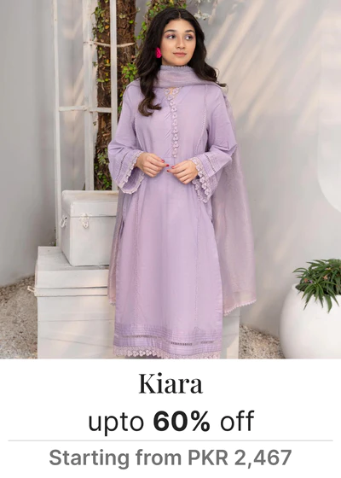 **Description of the outfit:**

* **Type: Dress**
* **Color: Light purple**
* **Material: Light weight**
* **Size options: XS, S, M, L, XL**
* **Style: Formal and elegant**
* **Care instructions: Hand wash, line dry**
* **Availability: In stock**